Quiz # 3 (A) Solution
Problem:
Show that the vectors $p=2x^{2}+x-1, q=x^{2}-3x+2, r=3x^{2}-2x+1$ are linearly dependent or independent.
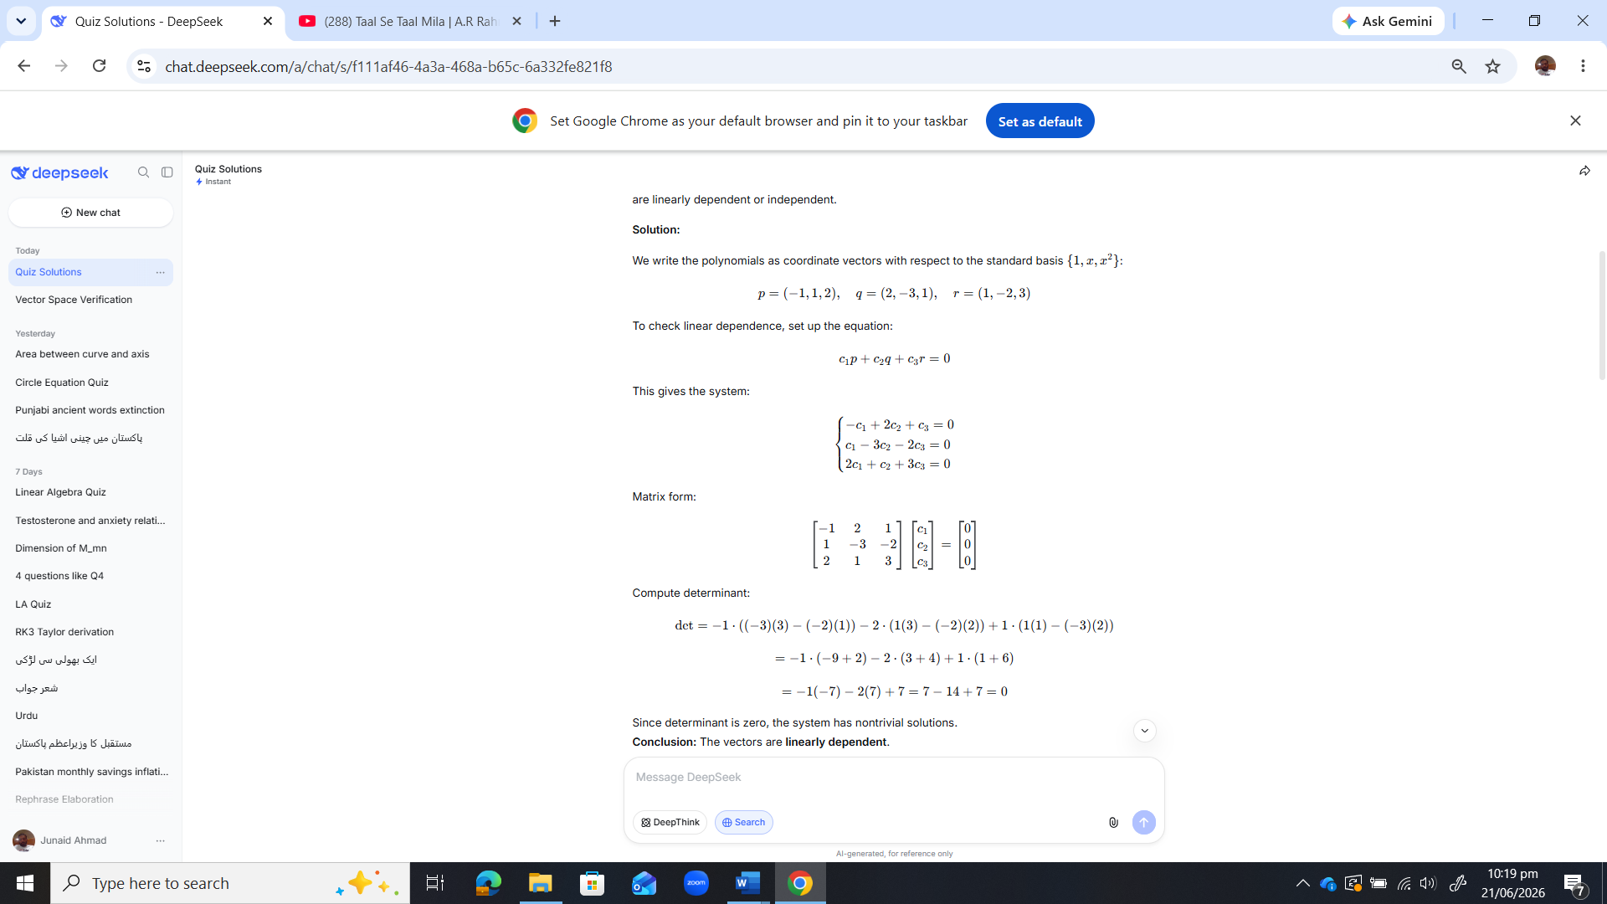
Solution:

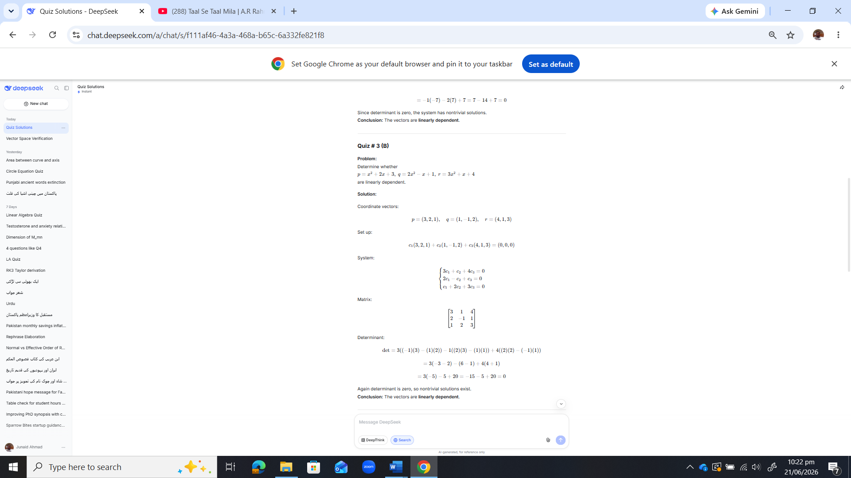
Quiz # 3 (B) Solution

Quiz # 4 (A) Solution
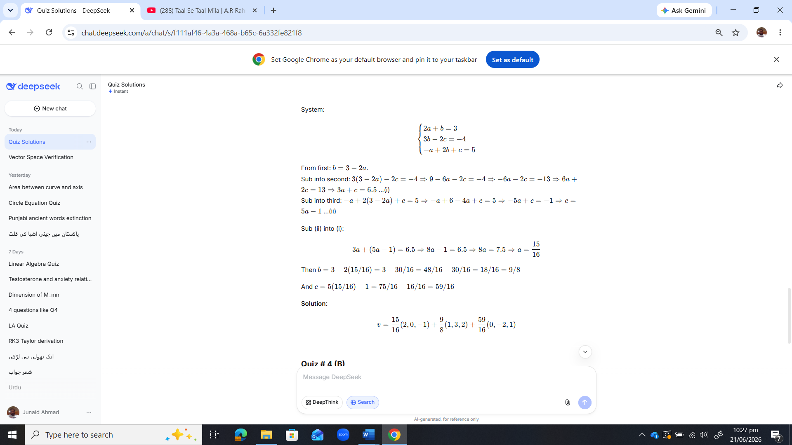
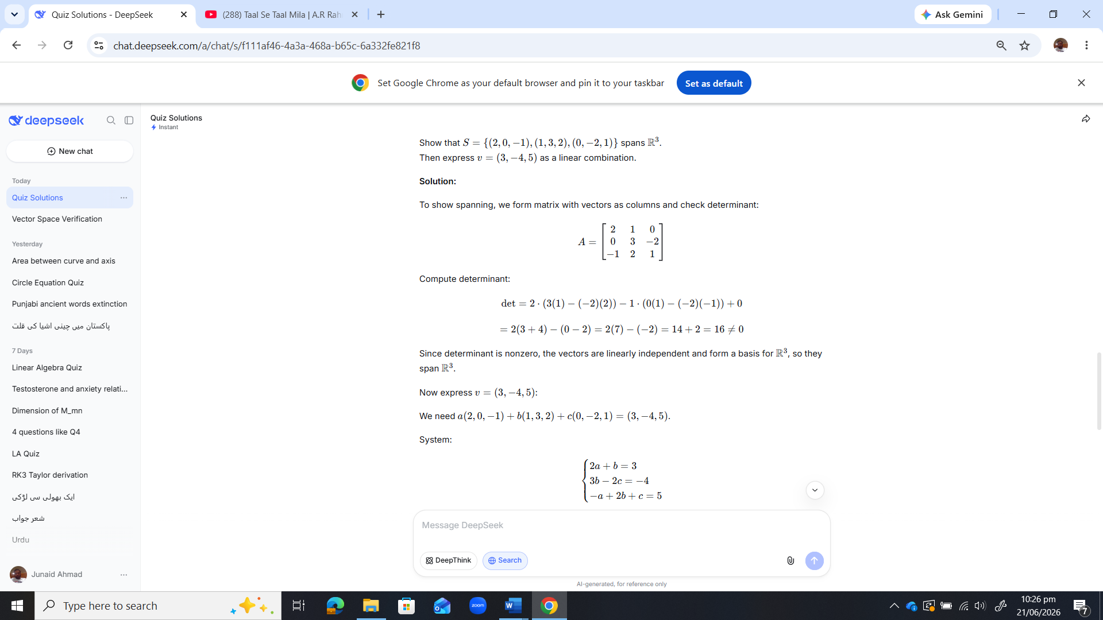

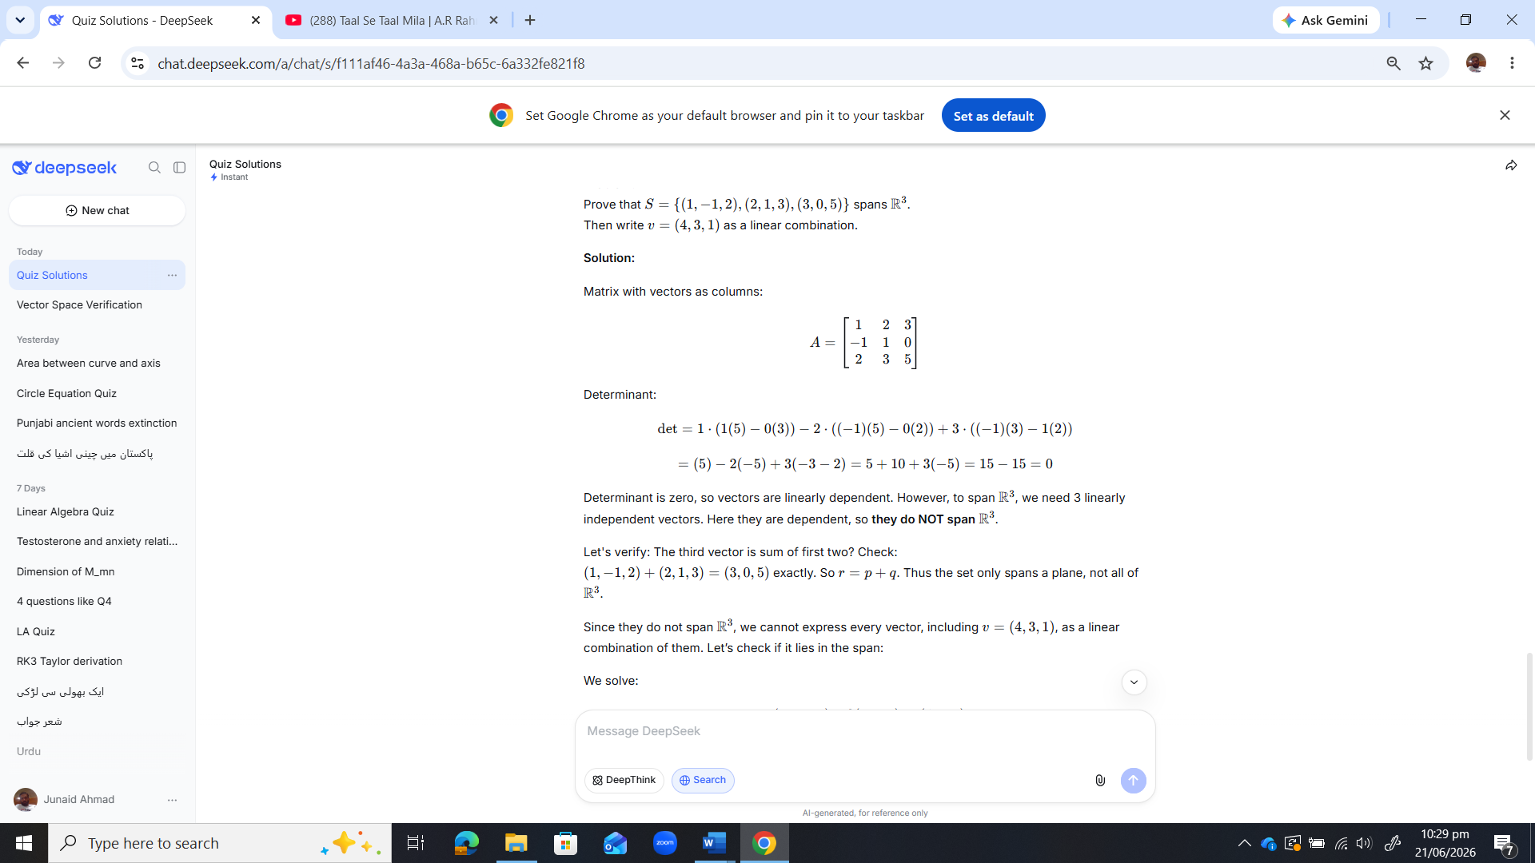
Quiz # 4 (B)

